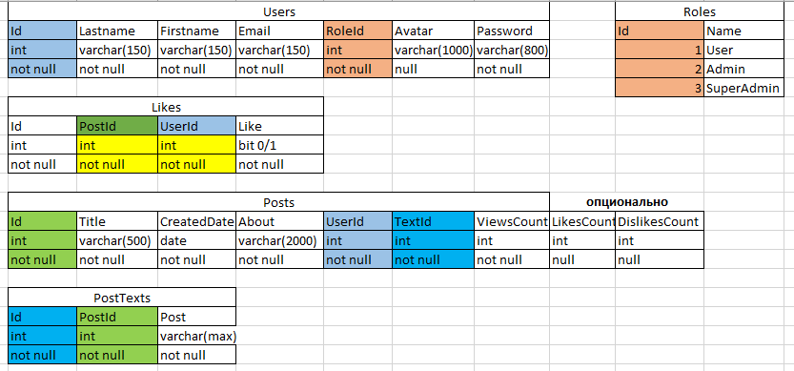

DROP TABLE blog.Users;

DROP TABLE blog. Roles;

DROP TABLE blog.Posts;

DROP TABLE blog.PostTexts;

DROP TABLE blog. Likes;

CREATE TABLE blog.Users

(

Id int not null,

Lastname varchar(150) not null,

Firstname varchar(150) not null,

Email varchar(150) not null,

RoleId int not null,

Avatar varchar(1000) null,

Password varchar(800) not null,

CONSTRAINT PK_Users

PRIMERY KEY (Id);

CONSTRAINT FK_Roles_Users

FOREGN KEY (RoleId)

REFERENCES blog.Roles (Id)

);

CREATE TABLE blog. Roles

(

Id int not null,

Name varchar(500) not null,

CONSTRAINT PK_ Roles

PRIMERY KEY (Id)

);

CREATE TABLE blog.Posts

(

Id int not null,

Title varchar(500) not null,

CreatedDate date not null,

About varchar(2000) not null,

UserId int not null,

TextId int not null,

ViewsCount int not null,

LikesCount int null,

DislikesCount int null,

CONSTRAINT PK_ Posts

PRIMERY KEY (Id)

);

CREATE TABLE blog. PostTexts

(

Id int not null,

PostId int not null,

Post varchar(max) not null,

CONSTRAINT PK_ PostTexts

PRIMERY KEY (Id)

);

CREATE TABLE blog. Likes

(

Id int not null,

PostId int not null,

UserId int not null,

Like bit not null,

CONSTRAINT PK_ PostTexts

PRIMERY KEY (Id)

);